INSURANCE PREMIUM PREDICTION

Wireframe Document

Anjali Joshi

iNeuron

Homepage

Homepage consists of the main landing page from where the user can navigate to different sections according to the need.

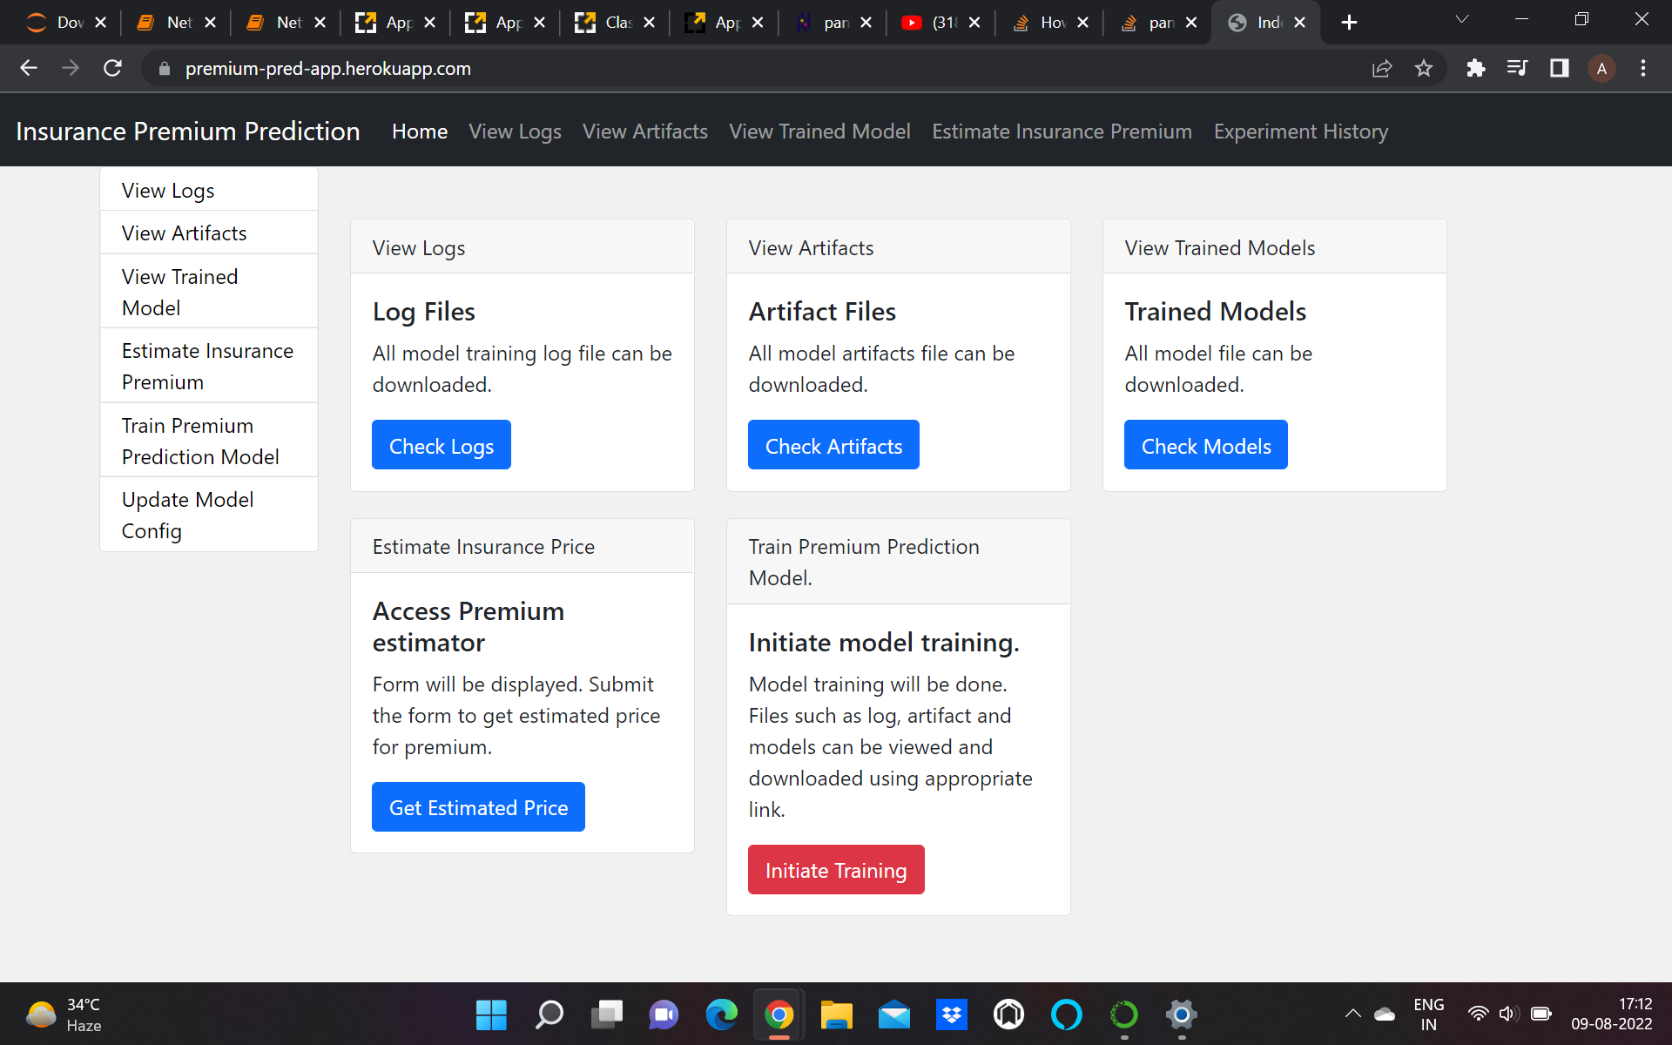

To predict the premium click on the Access Premium estimator

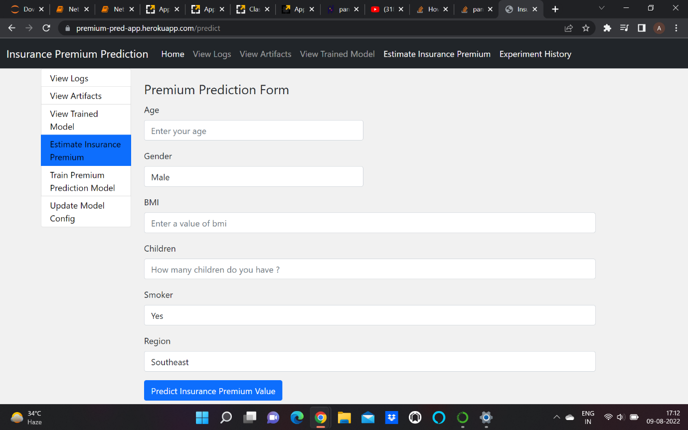

User can enter the values and get the estimated insurance premium.

Train the Model

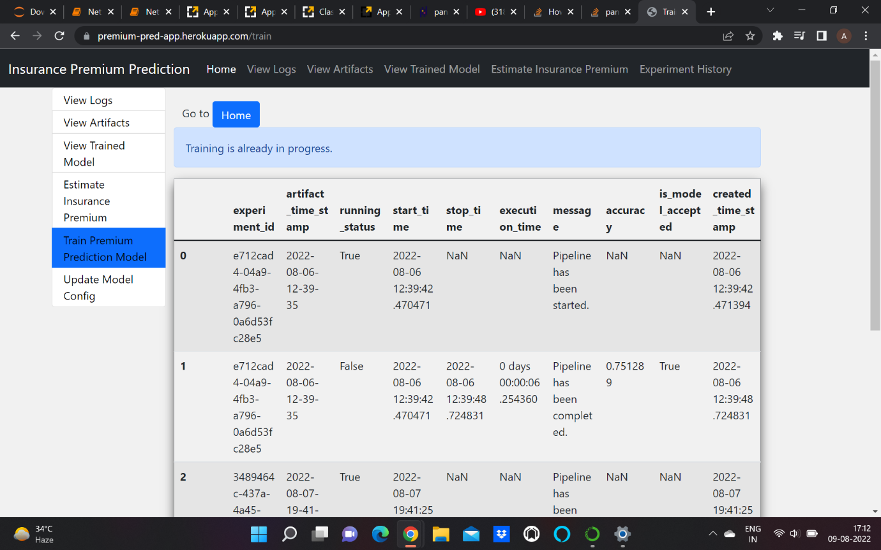

Initiate training will start the model training.

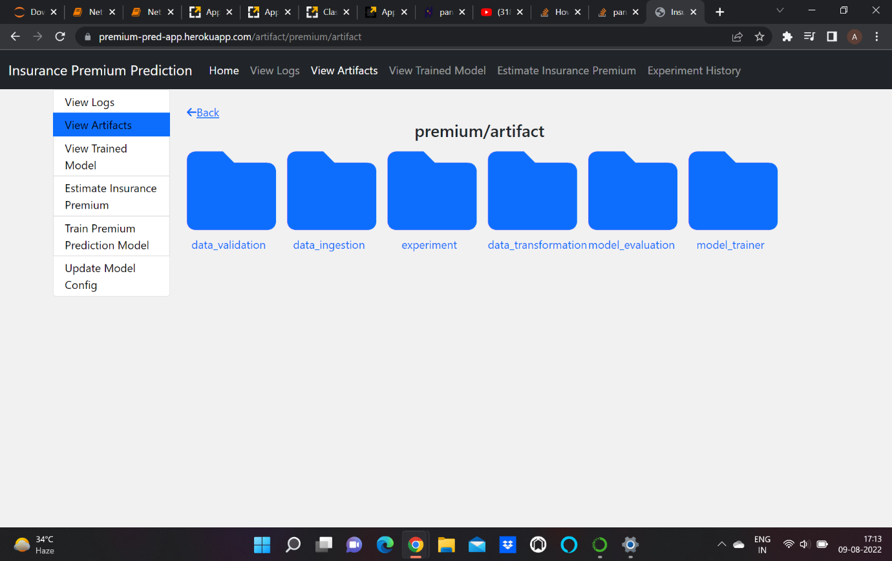

From this page the user can check and download all the artifacts that have been generated during the model training .

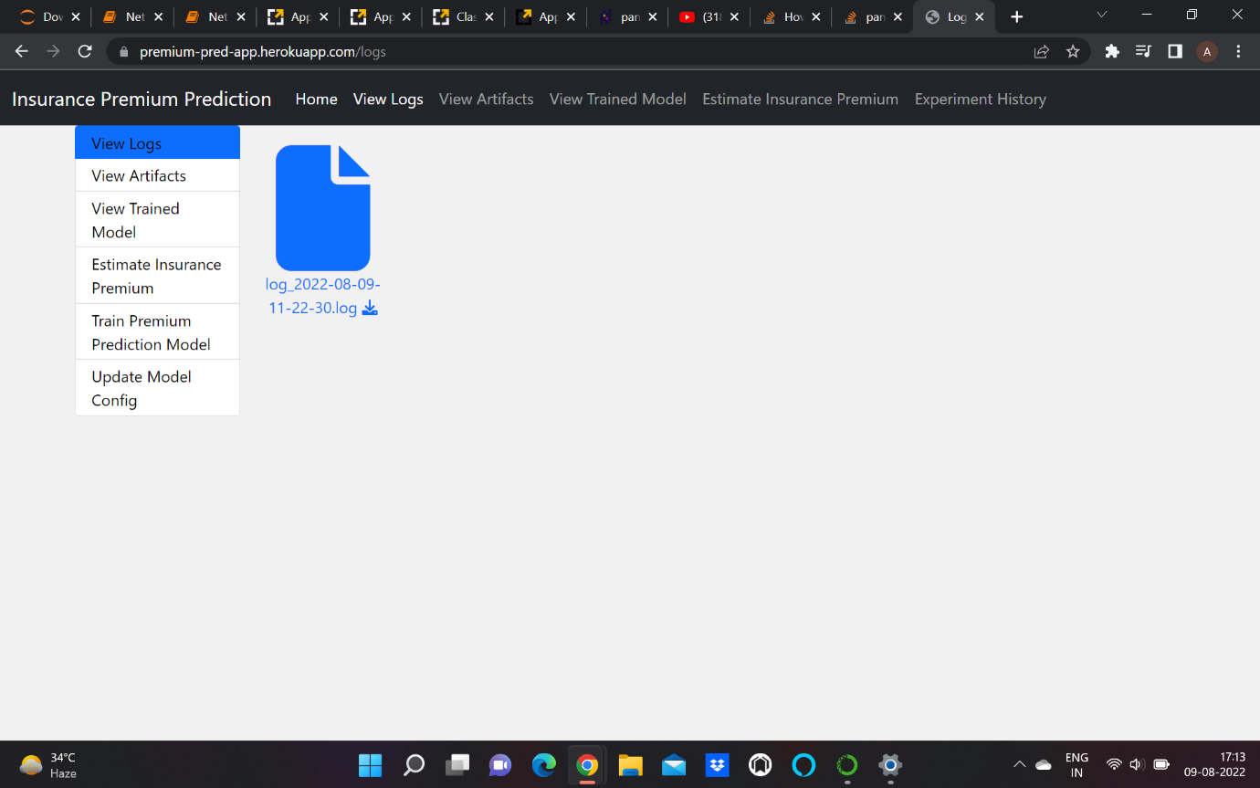

From here the user can check and download all the logs. All the steps will be logged here and user can check them here anytime.